MONTAGUE COUNTY 4-H AND FCCLA YOUTH FAIR
MONTAGUE COUNTY YOUTH FAIR GROUND at THE NOCONA FAMILY LIFE CENTER
Located at 605 Cooke St. Nocona, TX 76255
The Home Economics Division of the Montague County Project Show is open to students who are enrolled in Family and Consumer Sciences Education, Skills for Living, and FCCLA members, or active 4-H club members who have been enrolled with enrollment card on file with the county extension agent since November 1, 2010, and who have completed one home economics project by January 1, 2011.

SCHEDULE OF EVENTS
Thursday, January 13, 2011 4:30 – 6:30 p.m. No project accepted after 6:30 p.m.
Check in Crafts, Fabric Construction, & Photography Projects
Judges arrive 7:30 p.m.

Friday, January 14, 2011 9:00 – 11:00 a.m. No food project accepted after 11:00 a.m.
Check in Food Entries
Judges arrive 11:30 a.m.

Saturday, January 15, 2011 7:30 a.m. – 1:00 p.m. Public viewing of Projects/Silent Auction
1:00 p.m. – 2:00 p.m. Pick up all projects and clear building
5:45 p.m. Premium Auction Participants Line Up
6:00 p.m. Premium Auction

GENERAL RULES
- Entries will be divided by current school grade: 3rd through 7th grade; 8th grade through high school. Clover kids will register on-site and all kids will receive Participant ribbons; they are not eligible to make a sale.
- All exhibitors are subject to UIL no pass/no play regulations.
- Each exhibitor is limited to one entry in each class, and may enter all classes in each division.
- All entries must have been made since the last county show and constructed by the exhibitor.
- All entries are $3.00 each and must be registered online (A ShoWorks number will be assigned when you enter online); turn in entry form and a printed copy of your online register to the FCCLA teacher, or 4-H leader by December 15, 2010. All entries must be turned in to your teacher or club manager. All entry classes are final and may not be changed by the entrant after registration. No entry fee refunds will be made. Go to http://montague-tx.tamu.edu for more information.
- Grand and Reserve Champion in each division will have the option to sell in the premium sale. Only two items in premium sale per exhibitor (Animal, Shop, or Home Economics). Those entries eligible for the premium sale will not receive first place ribbon money. Sole entry in any category does not assure participant of a blue ribbon. Each entry must meet specified quality guidelines in order to sell. Premium sale items will have commission percentage deducted. Each exhibitor will only be able to sell one item in each division to the premium sale (one food, one craft, one fabric, and one photograph).
- Each exhibitor will sell their own items during the premium sale. Use of a stand-in to sell items must be pre-approved by county extension agent by 2:00 p.m. Saturday. Excused absences include illness or conflicting school activities.
- All decisions by the judges are final.
- First through tenth place ribbons will be awarded in each class. Participation ribbons will be awarded for all others. Prize money is given to 1st through 5th place. Grand and Reserve Champion rosettes will be awarded in each division. The Sweepstakes winner must have entries in all four divisions. Sweepstakes plaques will be awarded in both divisions.
- All projects must display entry number ONLY.
- Under no circumstances will students or spectators be allowed in the display area during judging.
- Prize checks will be distributed to FCCLA teachers and 4-H managers approximately two weeks after show. Checks should be cashed by April 15, 2011. After this date, checks will be voided. Collection of silent auction monies will be the sole responsibility of the exhibitor.

DIVISIONS

FOOD
- No entry that requires refrigeration will be placed. This includes uncooked dairy products such as milk, evaporated milk, real butter, cream cheese, sour cream, whipped topping, fresh fruit, etc. Chess and Buttermilk pies are not accepted. Margarine is acceptable. A fact sheet is attached, please read it.
- All entries should be entirely from scratch except creative cakes, which contain a cake mix; decorated cake may be from scratch or mix.
- All food entries are to be on or in disposable containers. Cakes should be on a foil covered board no more than 2 inches larger than product and covered with clear wrap (no color or decoration) or in a disposable pan with clear cover. For display, candy and cookies should have one dozen; bread should have one loaf. Item should be on a white, 9 inch disposable plate covered with clear wrap or a zipper style bag. The remaining recipe will be left at home for possible premium auction opportunity.
- ONE copy of the recipe must be attached on a 4x6 index card. Typing is preferred; computer print-out cut and placed on index card will be accepted, as well as hand printed recipe cards. More than one index card may be used. No 3x5 cards will be accepted.
- Class 6 & 7: All icing, frosting, or glazing must be made from scratch.
- Class 13 – 16: Must present 1 pint size jar of properly sealed product for judging. Jars must have brand name on the side of the jar (Kerr, Mason, Ball, etc). Recipe must reflect processing and safe sealing. See attached fact sheet. Do not place label or decoration of any kind on jar or lid. Mayonnaise jars and the like will be disqualified. If the entry qualifies for premium sale or silent auction, 3 jars will be sold. No refrigeration products allowed.
- Food will be judged according to texture, color, flavor, appearance, and difficulty of recipe.

- Candy: Must be cooked, no mixes. | - Melted candy covered snacks: Candy base; ingredients must be melted.
- Cookies: Drop, rolled, shaped, or pressed; baked cookies only, no cookie mixes. | - Cookies: Bar type; baked cookies only, no cookie mixes.
- Creative Cake: Must use cake mix as a base | - Scratch Cake: May use frosting, glazing, or icing. No mixes
- Decorated Cake: Must fit on 12”x15” board, may use ready made icing. | - Quick Bread: No mixes.
- Yeast Bread: No mixes; no bread machine. | - Fried Pies (4) Must be in a single 9” disposable pie pan or disposable plate.
- Pie: No cobbler, cream, meringue, or ice box; scratch crust only. Must be in a single 9” disposable pie pan. No mixes.* | - Jerky: Pound non-cured meat constitutes full recipe.
- Relish | - Jam or Jelly
- Pickles/Vegetables | - Salsa

FABRIC CONSTRUCTION

- Garments must be clean and pressed. Soiled garments will be disqualified.
- All items of major construction must be machine stitched.
- If applicable, place clothing on a hanger.

- Apron or Vest | 2. Jumper or Short set (no collar, no sleeves)
- 1 or 2 piece outfit (with collar and/or sleeves) | - Skirt, Pants, Jams (drawstring or elastic waist)
- Skirt, Pants, Jams (waistband and closure) | 6. Organizer (tote bag, garment bag, locker organizer, etc)
7. Homemade Pillow (must be machine sewn) | 8. Home Sewn Accessory (tablecloth, pillow case, napkin, curtain, place mat, table runner, etc)
- Sewn Hat, Cap, Tie, Purse | 10. Animal Accessory (dog clothes, goat/sheep coat, horse blanket, etc)
11. Specialty (costume, uniform, bathing suit, etc) | - Doll clothes
- Green Item | 14. Quilting or piecing: Wall hanging, pillow, bedding, etc (hand or machine stitched through 3 thicknesses of fabric.

Items will be judged according to accuracy of cutting, quality of work as it contributes to the professional look considering the following: machine work, finishing techniques, coordination of fabric to pattern, appropriateness of buttons, zippers, and appliqué to the pattern and fabric, and degree of difficulty.

CREATIVE ART
- Home Decorated Item: Photo albums, frame, lamp shade, etc. | - SENIORS ONLY: Interior Design 1 room floor plan & design elements (maximum size 16”x20”)
- No Sew Accessory: Blankets, scarves, pillows, macramé, etc. | - Needlework: Needlepoint (fabric or plastic canvas, embroidery, cross stitch, etc.
- Knitting or Crochet | - Framed Pen and Ink on Glass (maximum size 16” x 20”).
- Fashion Accessory: Belt, Cap, Tie, Purse, etc. | - Original Art: Must be able to be displayed on table (maximum size 20” x 20”).
- Jewelry: Necklace, earrings, bracelets. | - Decorated Clothing: Painted t-shirt, hat, tie-dye, shoes, etc.
- Tree Ornament for any season – One only. | - Floral Arrangement: Artificial (maximum table area is 16” x 24”).
- Decorated Golf Ball: Take a golf ball(s), make a conversation piece. | - Home Made Candles: One only (maximum 6” diameter) Need recipe attached on 4x6 index card.
- Wreaths: Artificial (maximum size: 18 inch diameter).

Creative arts projects will be judged according to workmanship, appropriate material/color harmony, degree of difficulty, original design, and presentation. Projects must be clean and in new condition.

PHOTOGRAPHY

- One 8” x 10” color, or black and white, photograph per class can be entered
- The photo must be displayed in a page protector.
- Negative or digital equivalent must be available on request for verification.
- Professional photographers will judge class.
- For Economic Development Award: Cash prizes awarded to 1st through 3rd place.

- Digital Photograph: People or Animals | 2. Digital Photograph: Nature (landscape, flowers, etc) | - Digital Photograph: Architectural (buildings, bridges, etc)
- Non-Digital Color Photograph: People or Animal | - Non-Digital Color Photograph: Nature (landscape, flowers, etc) | - Non-Digital Photograph: Architectural (buildings, bridges, etc)
- Non-Digital Black and White Photograph: People or Animal | - Non-Digital Black and White Photograph: Nature (landscape, flowers, etc) | - Non-Digital Black and White Photograph: Architectural (buildings, bridges, etc)

2010 Montague County Youth Fair Entry Form

FOOD | ** | Min. bid | FABRIC CONSTRUCTION | ** | Min. bid | CREATIVE ART | ** | Min. bid
1. Candy |  |  | 1. Apron or Vest |  |  | 1. Home Decorated Item
2. Melted Candy |  |  | 2. Jumper or Short set |  |  | 2. SENIORS ONLY!
3. Cookie |  |  | 3. 1 or 2 piece Outfit |  |  | 3. No Sew Accessory
4. Cookie (bar) |  |  | 4. Skirt, Pants, Jams (elastic) |  |  | 4. Needlework
5. Creative Cake |  |  | 5. Skirt, Pants, Jams (waistband) |  |  | 5. Knitting or Crochet
6. Scratch Cake |  |  | 6. Organizer |  |  | 6. Frame Pen & Ink on Glass
7. Decorated Cake |  |  | 7. Homemade Pillow |  |  | 7. Fashion Accessory
8. Quick Bread |  |  | 8. Home Sewn Accessory |  |  | 8. Original Art
9. Yeast Bread |  |  | 9. Animal Accessory |  |  | 9. Jewelry
10. Fried Pie |  |  | 10. Sewn Hat, Cap, Tie, or Purse |  |  | 10. Decorated Clothing
11. Pie |  |  | 11. Specialty |  |  | 11. Tree Ornament
12. Jerky |  |  | 12. Doll Clothes |  |  | 12. Floral Arrangement
13. Relish |  |  | 13. Green Item |  |  | 13. Decorated Golf Ball
 |  |  | 14. Quilting/Piecing
14. Jam or Jelly |  |  | PHOTOGRAPHY (circle appropriate numbers) |  |  | 14. Home Made Candle
15. Pickles/ Vegetable |  |  | 1. Digital [ 1, 2, 3 ] |  |  | 15. Wreath
16. Salsa |  |  | 2. Non digital color [ 4, 5, 6 ]
 |  |  | 3. Non digital b & w [ 7, 8, 9 ]
Number of entries | x | $3.00 = | Total Entry Fee Due | $

Exhibitor (Print Name)___________________________________ If eligible, do you wish to participate in the Premium Auction? Yes or No
Current School Grade & DOB_____________________________ If eligible, do you wish to participate in the Silent Auction? Yes or No
Signature of Exhibitor____________________________________ To qualify for the silent auction, you must fill in minimum bid (as noted above).
Signature of Parent/Guardian______________________________ This is the lowest amount you will accept for the project.
Signature of 4-H or FCCLA Leader_________________________ Photography: Economic Development Award
Club Name____________________________________________ Was your photo entry taken in Montague County? Yes or No
If yes, have you signed written permission to publish? Yes or No

Controlling FAT TOM Conditions

You can control FAT TOM conditions by the following methods:
Keep food out of the temperature danger zone of 41 degrees to 140 degrees Fahrenheit, by refrigerating the food.
Increase the amount of acidity in food, by adding vinegar to the food.
Decrease the water activity in food, by drying the food.
Eliminate the oxygen supply, by canning the food or using oxygen reduced packaging.

TEMPERATURE DANGER ZONE

The temperature danger zone, 41 to 140 degrees Fahrenheit, is critical because microorganisms, especially bacteria, grow best at these temperatures. At these temperatures and under the right conditions bacteria can multiply approximately every 20 minutes. Bacteria grow most rapidly at temperatures between 70 and 120 degrees Fahrenheit.

____________140 ° F


____________120° F

Temperature Bacteria multiply most rapidly
Danger Zone at temperatures between
41°F – 140°F 70°F – 120°F
_____________70° F

_____________41° F

MONTAGUE COUNTY YOUTH FAIR

How does this food safety guideline relate to the food you enter in the Montague County Youth Fair? Recipes that call for uncooked milk, including canned milk, cream cheese, whipped cream, butter, sour cream, and other potentially hazardous foods will be disqualified due to risk of food-borne illnesses. Projects containing these ingredients will remain in the danger zone for too long.
Margarine is not a dairy product but should be kept in the refrigerator because it becomes rancid very quickly if left at room temperature for too long. It represents a food quality issue, not a food safety issue; therefore, it may be used in your food entry.
Fresh strawberries and cherries should also be refrigerated because of high water content and therefore may not be used.

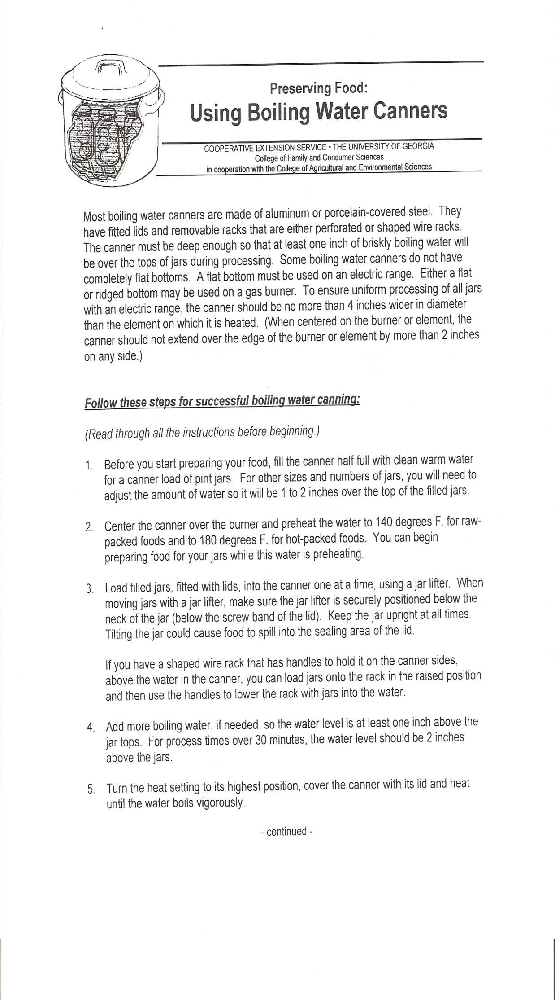
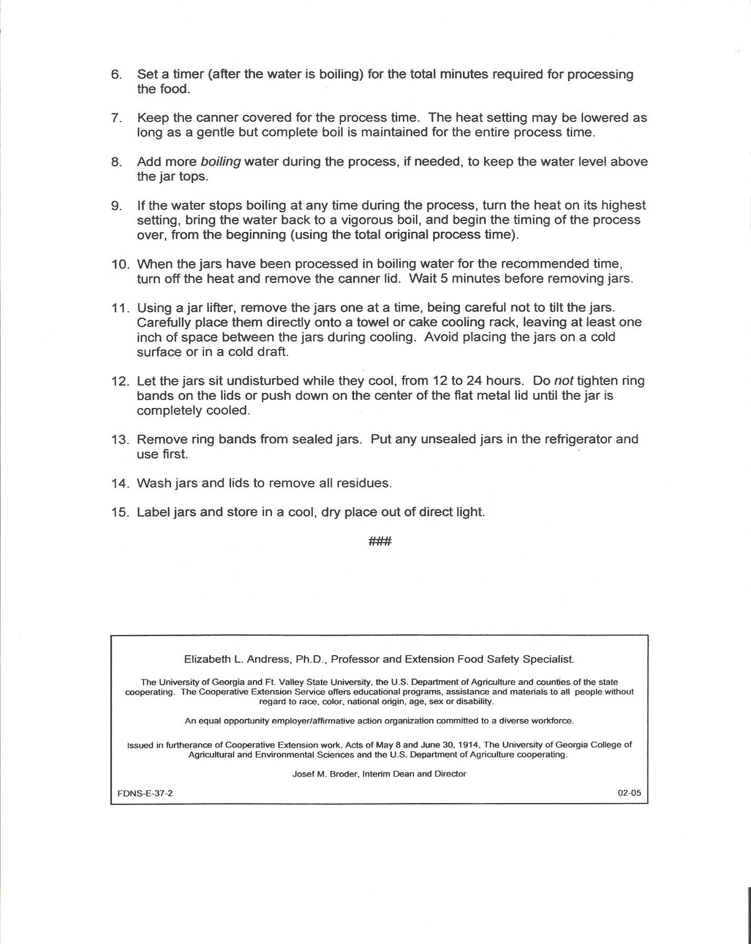

FOOD
Judged by  team # | Description | Points | Comments | Final  Score
GUIDELINES  FOLLOWED | Correct  Refrigeration  Display  Recipe Cards | 20
APPEARANCE &  PRESENTATION | Visually Appealing  Pleasing aroma  Appropriate Garnish | 30
EXECUTION AND  DIFFICULTY OF  RECIPE | Not over or under done  Moist or too dry  Difficulty of Project | 30
TASTE | Good flavor  Texture is appropriate | 20
TOTALS |  | 100

Entry #__________________________Class_________________________________

FABRIC CONSTRUCTION

Judged by  team # | Description | Points | Comments | Final  Score
GUIDELINES  FOLLOWED | Qualifications  Clean/Pressed  Machine stitched | 20
APPEARANCE &  PRESENTATION | Coordination of fabric to pattern  Appropriate notions | 30
EXECUTION  OF  PROJECT | Machine work  Finishing techniques  Accuracy of cutting | 30
DEGREE OF DIFFICULTY | Difficulty of sewing project  Sewing Skills | 20
TOTALS |  | 100
Entry #__________________________Class_________________________________

CREATIVE ART
Judged by  team # | Description | Points | Comments | Final  Score
GUIDELINES  FOLLOWED | Qualifications vary by category  Size/Technique/Amount  Clean/New Condition | 20
APPEARANCE &  PRESENTATION | Appropriateness of material  Color harmony | 30
EXECUTION  OF  PROJECT | Creativity/original design  Techniques  Accuracy of execution of design | 30
DEGREE OF DIFFICULTY | Difficulty of project  Workmanship  Skills used | 20
TOTALS |  | 100
Entry #__________________________Class_________________________________

PHOTOGRAPHY (CIRCLE ONE) A B C
A. People or animals B. Nature (landscapes, flowers, etc) C. Architectural (buildings, bridges, etc)
Entry #__________________________Class_________________________________
Judged by  team # | Description | Points | Comments | Final  Score
GUIDELINES  FOLLOWED | Correct mounting  Negative or  Digital equivalent  provided | 20
APPEARANCE &  PRESENTATION | Neatness of mounting  Print Quality | 30
SUBJECT | Creative use of subject  Composition  Impact  Uniqueness | 20
TECHNICAL | Focus  Exposure  Lighting | 30
TOTALS |  | 100

